WD My Cloud EX2 Ultra 2-Bay Personal Cloud Storage Server (Diskless) NAS (CZONE)

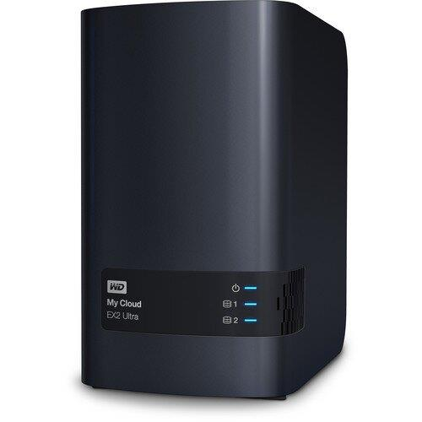

**Key Features**

* **Model**: WD My Cloud EX2 Ultra (Diskless)
* **Form Factor**: Desktop (2-Bay NAS)
* **Processor**: 1.3 GHz Dual-Core Processor
* **RAM**: 1GB DDR3 RAM

**Performance and Hardware Features**

* **Processor**: Powered by a **1.3 GHz dual-core processor**, the EX2 Ultra offers solid performance for both personal and small business users who need fast and reliable storage for media, backups, or file sharing.
* **Memory**: Equipped with **1GB of DDR3 RAM**, the device can handle moderate workloads, ensuring smooth access and transfer speeds for multiple users or devices connected to the network.

**Warranty Information**

* **Limited Warranty**: The **WD My Cloud EX2 Ultra** comes with a **2-year limited warranty**. This warranty covers defects in materials and workmanship, providing peace of mind for users who rely on the device for important data storage and backup.